Mid Back Exercises (Group #2)

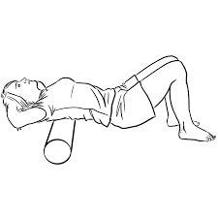
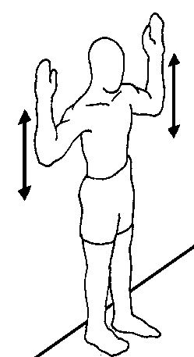
Wall Angles
Slowly raise and lower arms 10x
Keep head, arms, and back against wall.
Lying vertically on the foam roller. Slowly move your arms above your head until you feel a good stretch. Hold
each stretch for 30-60 seconds.
Corner Stretch
Lean forward into corner until a comfortable stretch is felt across chest.
Hold 30 seconds.
Repeat 2 times.
Pt Handouts Exerc/MdBk/ Exerc 2 Foam Roller
Wall Slide- Slowly slide back along wall as you bend your knees, comfortably- 5x
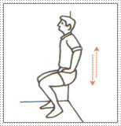
- 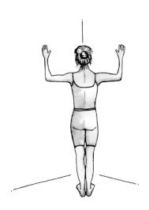

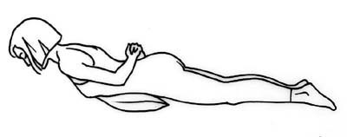
Upper Body Extension
Raise elbows, then lift upper body off floor Keep chin tucked. Hold 3 seconds. Build up to 20 times.

- 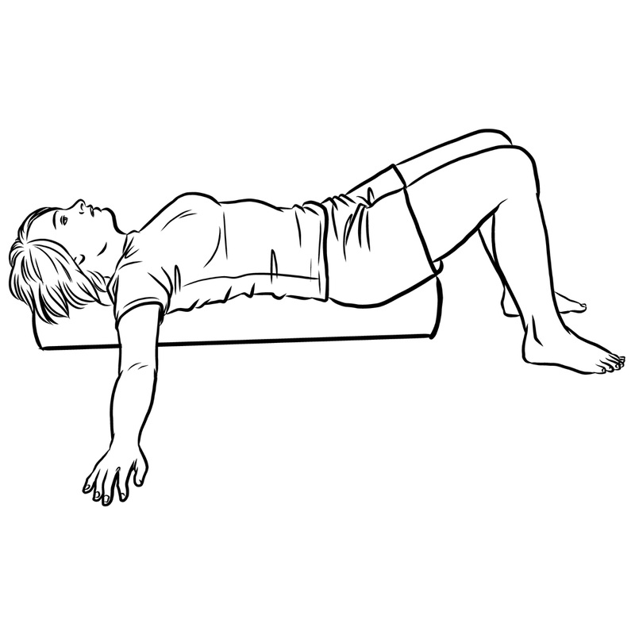

Slowly work the roller for 30 seconds up and down your upper back – from shoulder blades to your middle back (not your lower back).

Corner Stretch
Lean forward into corner until a comfortable stretch is felt across chest.
Hold 30 seconds.
Repeat 2 times.

